
Correction Final Exam – Computer Vision 2022

Part 1 (10 points - 50 mns): Geometric transformations
Question 1 (3 points - 15 mns): For each of the transformations below state which kind of transformation Ti was used (projective, affine, Euclidean, similarity, other).
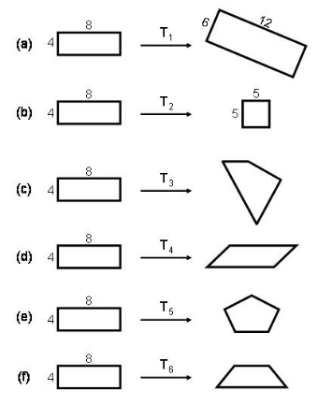
Ans:
(a) Rotation + Same scaling (x1.5) => similarity
(b) Different scaling (x5/4 and in the other direction x5/8) => Affine
(c) Parallel lines are distorted in the two directions => Projective
(d) Parallel lines in one direction are distorted but preserved in the other direction => Affine
(e) Other (as the shape is now defined by 5 segments)
(f) ) Parallel lines in one direction are distorted but preserved in the other direction => Projective

Question 2 (2 points - 10 mns): When intrinsic and extrinsic parameters are unknown, and key points between left and right views can be matched, why the reconstruction of a 3D scene from a stereo camera setup can be done up to a 3D projective transformation? (Hint: draw a figure.)
Ans. See Lecture 5a slide 17
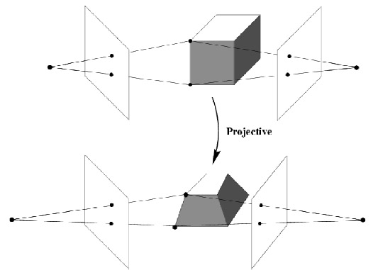
Study case 1: A camera is imaging the scene in the picture below, resulting in image I1. The camera is then rotated, and a second picture I2 of the scene is taken. The camera is then moved to another location, and a third picture I3 of the scene is taken.
Hint:


I₁
I₂
I₃
f

R₁₃, t₁₃

Question 3 (2 points - 10 mns): What is the geometric relation between the images I1 and I2? What is the minimum number of corresponding points between the two images required in order to recover this relation?

Ans: It’s a Euclidean transformation with 3 DOF maximum (for the rotation); With two equations per corresponding points (3D vs 2D) and two corresponding points we will have 4 equations, it’s enough to recover the 3 unknowns.

Question 4 (1 point - 5 mns): Same question as above for I1 and I3?

Ans: It’s a Similarity transformation with 6 DOF maximum (3 for the rotation, 3 for the translation); With two equations per corresponding points (3D vs 2D) and three corresponding points we will have 6 equations, it’s enough to recover the 6 unknowns.

Study case 2: The camera now zooms in, so that it sees only the flat scissors, producing image I4. The camera is then moved again to another position, taking another picture of the scissors, resulting in image I5.

Hint:

f
I₄
I₅

R₄₅, t₄₅

Question 5 (1 point - 5 mns): What is the geometric relation between the images I4 and I5? What is the minimum number of corresponding points between the two images required in order to recover this relation?

Ans: It’s a Similarity transformation with 6 DOF maximum (3 for the rotation, 3 for the translation). With two equations per corresponding points (3D vs 2D) and three corresponding points we will have 6 equations, it’s enough to recover the 6 unknowns.

The experiment in study case 2 is repeated, but this time the opening angle between the two arms of the scissors is changed between the time I4 is taken and the time I5 is taken. Assume point correspondences between I4 and I5 are provided for each arm of the scissors (as many points as necessary).

Hint: If the opening angle between the two arms is changed that means the shape of the 2D plane shown below is distorted by a 2D affine transformation (which doesn’t preserve angles) or a projective transformation.

Before After

Question 6 (1 point - 5 mns): How can the axis point of the scissors be recovered?

Ans: a 2D affine transformation has 4 DOF (corresponding to the two rotations transform applied), meanwhile a 2D projective transformation has 6 DOF (if we consider that there is no translation). To recover these 4 or 6 unknowns, we must have 3 corresponding points (as we have 2 equations corresponding per points), we could use the intersection point between the two arms and the extremal point of each arm.

Part 2 (6 points - 30 mns): Pose estimation with relative depth priors

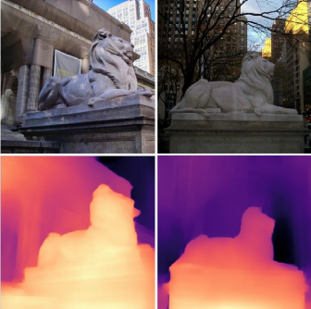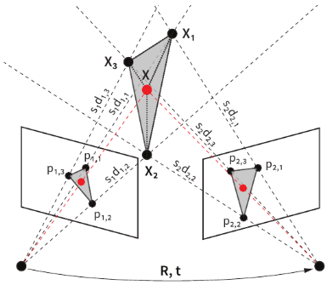

Question 7 (2 points - 10 mns): Writing p1 = (x1, y1, 1)^{T} and p2 = (x2, y2, 1)^{T} matching points in a stereo pair, with relative depth d1 and d2 (up to scale factors s1 and s2), explain why they are linked through
s2 d2 p2 = s1 d1 R p1 + t

with R and t the relative rotation and translation between the two views.

Ans: From the epipolar constraint we can state that:

If we assume that the world frame corresponds to the left camera frame X1 (ie M₁ = K₁ [I|O]) then M₂ = K₂ [R|t] (corresponding to the right camera frame X2), i.e. the two camera frames X1 ͼ R³ and X2 ͼ R³ are related by a rigid-body transformation in the following way:
X2 = R X1 + t.

Let x1, x2 ͼ R³ be the homogeneous coordinates of the projection of the same point P in the two image planes. Since Xi = (si di) xi, i = 1,2, the previous equation can be written in terms of coordinates xi and the depths (si di) as:
(s2 d2) p2 = R ( (s1 d1) p1) + t
Then (s2 d2) p2 = (s1 d1) R (p1) + t

Question 8 (2 points - 10 mns): Write 3 linear equations satisfied by the following 12 coefficients of a vector x composed of: 9 unknowns from (s1 d1) R, 3 from t and (s2 d2).

Ans:
t = (tx, ty, 1)^{T}
R = (R1, R2, R3)^{T} with Ri = (Ri1, Ri2, Ri3) and i=1, 2, 3
p2 = (x2, y2, 1)^{T} and p1 = (x1, y1, 1)^{T}

Then
(s2 d2) x2 = (s1 d1) R1 p1 + tx
(s2 d2) y2 = (s1 d1) R2 p1 + ty
(s2 d2) = (s1 d1) R3 p1 + 1

Question 9 (2 points - 10 mns): Assuming 4 or more matching pairs (p1; p2) are known, what is the procedure to recover R, t, (s1 d1) and (s2 d2) ?

Ans:

With 4 matching pairs known we will have 12 equations (3 per matching pairs), it’s enough to recover the 12 unknowns using a SVD method (based on the minimization of | AX |² under the constraint |X|²=1). The procedure consists to factorize in the 12 equations the unknowns in a vector X of dimensionality 12, and the knowns in a matrix A of dimensionality 12x12 such as AX = 0.

Part 3 (5 points - 25 mns): Multiple view constraints with lines

We assume n cameras in space, of calibration matrix K_{i}, oriented with rotation R_{i} and translation T_{i} with respect to some world coordinate frame.

Question 10 (2 points - 10 mns): Show that in general, the observation of a projection of a 3D line in a camera does not impose any constraint on its projection in another view.

Ans: To a 3D line corresponds a 2D line in each image plane.
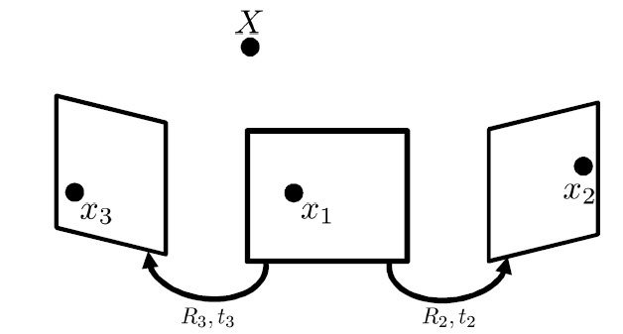

Question 11 (1 point - 5 mns): What is the exception?

Ans: When the projected points on one image (here the left one) overlap, in this case the corresponding 2D projections on the centered image are located on the corresponding epipolar line, likewise for the right image (epipolar constraint).

Question 12 (2 points - 10 mns): By a simple geometric consideration, show that the observation of the projections of a 3D line in two views determines the projection in a third view.

Ans:

E12 = [T₁₂] x R₁₂, E13 = [T₁₃] x R₁₃, E₂₃ = [T₂₃] x R₂₃.

We know that the point x₁ corresponding to x₃ is on the corresponding epipolar line specified by E₁₃ x₁. We also know that x₂ is on the corresponding epipolar line specified by E₁₂ x₁.

We also know that the point x₂ corresponding to x₃ is on the corresponding epipolar line specified by E₂₃ x₃. So x₂ is on the intersection of epipolar lines specified by E₂₃ x₃ and E₁₂ x_{1.}

Part 4 (8 points - 35 mns): Relative Pose from Line Correspondences

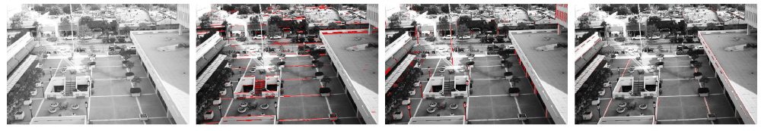Figure 1: Original image and three sets of parallel 3D lines in orthogonal directions.
v1
v3
v2

Question 14 (1 point - 5 mns): Under what geometric conditions is the vanishing point “at infinity”?

Ans: when parallel lines in 3D are not distorted in the 2D image plane, such as with an affine or a similarity transformation. As example see
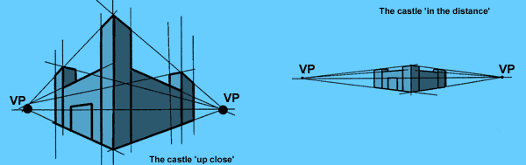 slide 41 of lecture 3a.

Question 15 (2 point - 10 mns): Show that if we align the world coordinate system with the three orthogonal vanishing directions in the scene (thanks to an K[R|t] projective transformation) then parallel lines in 3D along direction vector e, expressed in the coordinate system linked to the camera, are projected as concurrent lines, called vanishing point (“point de fuite” in French) such as v = K R e. See the figure above for examples of vanishing points.

Ans:
Let us align the world coordinate system with the three orthogonal vanishing directions in the scene (see figure above). At each point X along vanishing direction vi corresponds (thanks to the K[R|t] projective transformation) a projected point x such as λ x = K[R|t] X. Then at the 3D point e_{i} corresponds the 2D vanishing point vi such as :

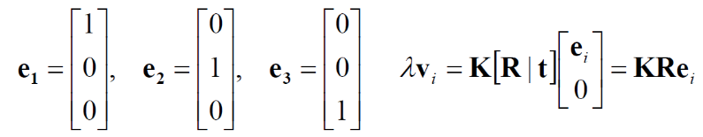

Question 16 (1 point - 5 mns): Demonstrate that λ K⁻¹ v_{i}= r_{i} where R = (r₁, r₂, r₃)

Ans:
From previous equation we have
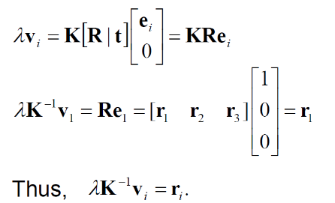

Question 17 (2 points - 10 mns): Show that vanishing points corresponding to orthogonal directions satisfy:
v₁^{T} (K^{−T} K⁻¹) v₂ = 0.

Ans:
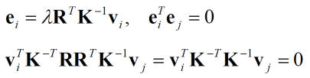

Question 18 (2 points - 5 mns): Supposing we have 3 three orthogonal vanishing points. Sum up an algorithm to compute R.

Ans:
- Solve for K (focal length, principal point) using three orthogonal vanishing points (see equation related to question 17)
- Get rotation R directly from vanishing points once K is known (see equation related to question 16)

It can be the product of three basic rotations Rx * Ry * Rz.
Here we do the assumption that there is no scaling effect, if we add a scaling another DOF should be considered.
See https://www.cs.princeton.edu/courses/archive/fall13/cos429/lectures/11-epipolar#page=26&zoom=auto,-252,487
The name pf this method is known as calibration from vanishing points. Advantages: No need for calibration chart (2D-3D correspondences), Could be completely automatic. Disadvantages: Only applies to certain kinds of scenes, Inaccuracies in computation of vanishing points, Problems due to infinite vanishing points.

